**MAX232**

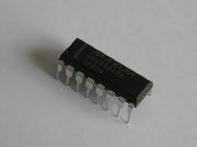

The MAX232 IC is used to convert the TTL/CMOS logic levels to RS232 logic levels during serial communication of microcontrollers with PC. The controller operates at TTL logic level (0-5V) whereas the serial communication in PC works on RS232 standards (-25 V to + 25V). This makes it difficult to establish a direct link between them to communicate with each other.

  The intermediate link is provided through MAX232. It is a dual driver/receiver that includes a capacitive voltage generator to supply RS232 voltage levels from a single 5V supply. Each receiver converts RS232 inputs to 5V TTL/CMOS levels. These receivers (R1 & R2) can accept ±30V inputs. The drivers (T1 & T2), also called transmitters, convert the TTL/CMOS input level into RS232 level.

The transmitters take input from controller’s serial transmission pin and send the output to RS232’s receiver. The receivers, on the other hand, take input from transmission pin of RS232 serial port and give serial output to microcontroller’s receiver pin. MAX232 needs four external capacitors whose value ranges from 1µF to 22µF.

|  |  |  |  |
| --- | --- | --- | --- |
| Microcontroller | MAX232 | | RS232 |
| Tx | T1/2 In | T1/2 Out | Rx |
| Rx | R1/2 Out | R1/2 In | Tx |

**Pin Diagram:**

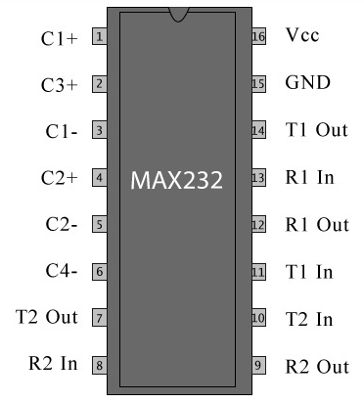

**Pin Description:**

|  |  |  |
| --- | --- | --- |
| **Pin No** | **Function** | **Name** |
| 1 | Capacitor connection pins | Capacitor 1 + |
| 2 | Capacitor 3 + |
| 3 | Capacitor 1 - |
| 4 | Capacitor 2 + |
| 5 | Capacitor 2 - |
| 6 | Capacitor 4 - |
| 7 | Output pin; outputs the serially transmitted data at RS232 logic level; connected to receiver pin of PC serial port | T2 Out |
| 8 | Input pin; receives serially transmitted data at RS 232 logic level; connected to transmitter pin of PC serial port | R2 In |
| 9 | Output pin; outputs the serially transmitted data at TTL logic level; connected to receiver pin of controller. | R2 Out |
| 10 | Input pins; receive the serial data at TTL logic level; connected to serial transmitter pin of controller. | T2 In |
| 11 | T1 In |
| 12 | Output pin; outputs the serially transmitted data at TTL logic level; connected to receiver pin of controller. | R1 Out |
| 13 | Input pin; receives serially transmitted data at RS 232 logic level; connected to transmitter pin of PC serial port | R1 In |
| 14 | Output pin; outputs the serially transmitted data at RS232 logic level; connected to receiver pin of PC serial port | T1 Out |
| 15 | Ground (0V) | Ground |
| 16 | Supply voltage; 5V (4.5V – 5.5V) | Vcc |